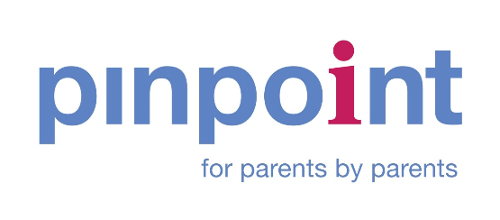
Pinpoint Forums Participation Group
Meeting Note 24 September 2024
Attendees: Lisa Belton, Pinpoint; Sarah Callaghan, CCC Director of Schools; Rebessa Salmon CCC Strategic Improvement Manager SEND Services 0-25; Katy Blesset, CCC Head of SEND; Brian Roberts, FASD Support Group
Apologies: Emma Harkin, CCC Head of SEND; Greg, Living Sport; Kathryn Goose, ICS Commissioning; Celia Enderle and Sue Berry, Cambridge Rare Disease Network Fran Cox, Assistant Director CCC; Michelle King Little Miracles; Claudia Holmes Cambridgeshire Downs Syndrome Group; Cambridgeshire Dyspraxia Group; Sharon Allen, Arthur Rank; Safe Soulmates; Justin Heron, Spectrum; National Autistic Society Cambridge; Janet Dullaghan, Pinpoint; Karlene Allen, ICS Commissioning; Salmon Rebecca, Strategic Improvement Manager SEND CCC

- Welcome
Sarah Conboy welcomed everyone to the meeting.

- Feedback (what’s working well, better if, urgent issues) and a wider discussion on current issues:
With just Brian present we focused on the experiences of families with FASD. We heard the expectations were raised following the NICE Guidance published in 2022, but it feels as if nothing has changed two years on. Cambridgeshire has no pathway or route to diagnosis, and it feels frustrating. If a parent carer can’t access a diagnosis by travelling to the Surrey FASD Clinic, then there is no alternative option. The FASD Support Group supports more than 100 families (Peterborough, Cambs and Lincs) and thinks that around 2% of the school population could have FASD. There is awareness that FASD might be included in wider neurodiversity pathways, but this doesn’t feel like the right solution, and there has been no real progress.
The Virtual School and the FASD Support Team have been working together nd are nominated for an award for their work. But beyond that there is no pathway, no support and no funding.
ACTION: Rebecca will ask health (John Peberdy) for clarity on how FASD might fit under an ND umbrella but with extra support and a diagnosis.
Sarah Conboy offered to review the signposting Pinpoint does already on FASD and to work with Brian if there is updated information or additional signposting that could be provided
ACTION: Brian will review what Pinpoint has on the site and offer thoughts on additional signposting and resources.

Brian has revamped a guide for teaching students with FASD. Sarah Conboy offered that if it could be shared, Pinpoint could consider whether it might be adapted to support parent carers.
ACTION: Brian will share the Guide for Teaching Studies with FASD, Rebecca, and Sarah.
ACTION: Rebecca offered to add FASD to the Ordinarily Available Tool Kit and work with Brian to develop the resource.
Sarah Callaghan suggested that the forthcoming CCC Inclusion Summit may be a place to explore how we support FASD, working alongside health colleagues.
We talked about encouraging professionals to ‘be curious’ about children’s needs, which everyone on the call felt was a helpful approach.
Sarah Conboy raised the potential link between the young people who struggle to stay in school as they transition to secondary school, Emotionally Based School Avoidance and the emergence of FASD-related issues at the same time, which could be seen in the same cohort.
We collectively discussed the importance of helping schools feel confident that they can meet needs, specifically SEN schools, to ensure there is always a school place.
ACTION: Sarah Callaghan will discuss ensuring SEN school providers have the training and confidence to provide for FASD children and young people.
Sarah Callaghan inquired whether we have a workforce strategy to support staff knowledgeable about FASD. Work was started as part of the All-Age Autism Strategy.
ACTION: Sarah Callaghan will discuss this with colleagues to explore how we train and support people with SEND in the workforce to become more SEND-confident and inclusive, including people with FASD.

