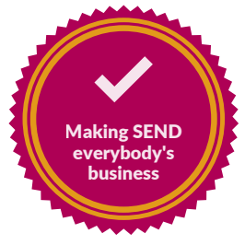

Co-production in Cambridgeshire
Whilst co-production can apply to any groups working collaboratively in policy development or service delivery, here we are specifically referring to co-production as it relates to Special Educational Needs and Disability. As the commitment to co-production is considered essential to how we work together, then the history of how Cambridgeshire came to commit to work in this way remains vital to understanding and retaining it as we move forward. You can find out more in Appendix 3.
Co-production in Cambridgeshire: what underpins how we work today
Co-production as opposed to consultation in parent-carer participation.

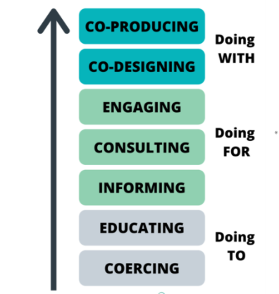

The Co-production Ladder sets out a hierarchy around participation. There are several definitions offered to explain the differences, but the definition below is helpful.
Consultation relies on an exchange of information, where the decision-making person or group engages in an exploration of ideas that takes advantage of dialogue, questions, and feedback. In consultation, the decision-makers and the contributors work together to surface mutual understanding, explore ideas, and articulate perspectives valuable to the decision-makers. Ultimately, however, once the process of consultation concludes, the decision-makers are left to determine the outcome.
Co-production provides a process for sharing decision-making power. In collaboration, the principal decision-maker/s invite/s others to join them in the process. Collaboration, like consultation, seeks to surface the best ideas through dialogue, exploratory questions, and identifying best practices. In co-production, however, it is the collective participants who determine the best way forward and make the decision together. ³
Cambridgeshire has committed to co-production, as opposed to a lower level of the ladder.

Co-production embedded in the new Cambridgeshire and Peterborough SEND Strategy

Cambridgeshire and Peterborough’s SEND Strategy and Pledge restates the commitment to co-production and uses the co-production infographic below.

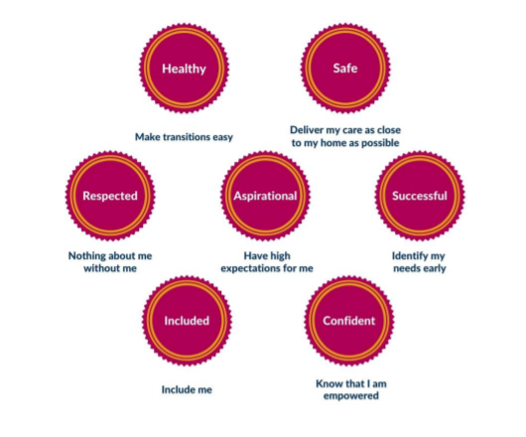

The Local Authority has reaffirmed that:
- The contribution from Pinpoint in developing the Local Authorities SEND policies, strategies and commissioned services is highly valued and respected by the Local Authority, with open, honest, and constructive exchanges being a feature of its work as the Parent Carer Forum.
- Co-production is the cornerstone of the reciprocal partnership where everyone’s voice and experience is valued, heard and considered in decision-making.
- Pinpoint, together with the Local Authority, supports and facilitates the involvement of parent carers in the commissioning and improving services for families of children and young people with SEND.
- Commissioners and parent carers, including the Forum, are committed to working together to achieve the principles set out in the Cambridgeshire and Peterborough SEND Strategy and its SEND Pledge.
- To achieve high-quality co-production at every stage Pinpoint will have a seat on all strategic Boards relating to SEND and its service delivery enabling sharing of insights, issues, and the co-production of solutions to address barriers and enablers senior system leaders can use to enhance SEND outcomes. (This can be seen in the structure diagram).
- Commissioners will work with Pinpoint to help plan for co-production through the LA Board and parent carer participation at every opportunity in the commissioning and (re)design of services.
- Pinpoint will ensure commissioners are fully engaged to and support the Forum and its representatives at the Pinpoint-hosted, termly Partners in Commissioning Meeting, which has its own terms of reference.
- Commissioners, officers, and Pinpoint representatives will use collaborative and facilitating approaches to establish and maintain working relationships with professionals across social care, education, and health with an enabling perspective.
- The Local Authority, and Pinpoint, will collect and collate parent carer views on relevant focused areas of activity relating to SEND policy, practices, and commissioning services.

In addition to Pinpoint being an independent Parent Carer Forum, it also contracts with the Local Authority to provide additional capacity to develop services through a profile of additional representation. In this process, parent carers use their lived experience to engage and (re)design and implement changes to services through direct and indirect involvement in strategic activity for SEND and aligned Council services. Pinpoint assists in the collation of parent carer views on relevant focused areas of activity relating to the co-production of services. It also provides feedback to enable service commissioners to evaluate the services they commission and to consider how well services meet the needs and aspirations of the children, young people, and families they provide for.

A new Co-production Toolkit for Commissioning 2021 - 2022
Commissioners embarked on the development of a co-produced toolkit in 2021/2022 to support service commissioners in the work.

