Health Appointment Survey Report
Feb 24

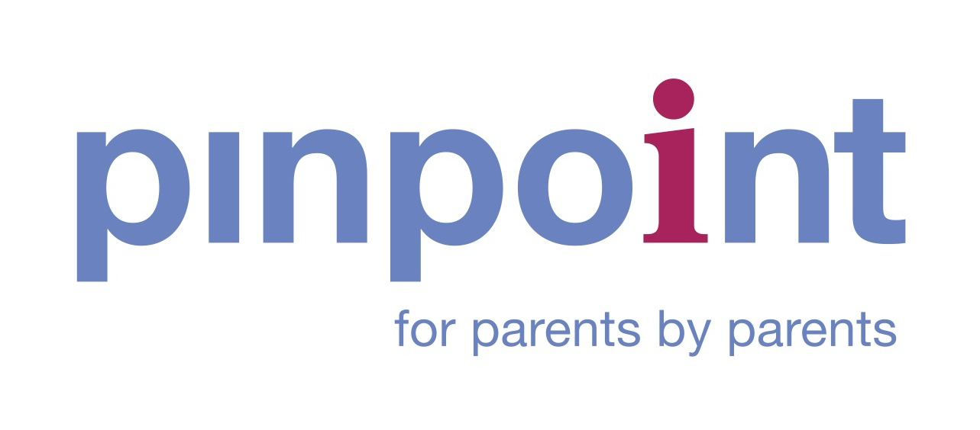
Summary Headlines
We haven’t run a health appointment survey before, so we have no comparative data for Cambridgeshire. However, our Annual Survey and this year’s mid-year survey include health satisfaction questions, which we’ll reference in this report. This is the first of two surveys that will feed into the health inequalities work we are working on with the Cambridgeshire and Peterborough Integrated Care System.
We had 54 respondents, so this isn’t a statistically valid representation, but the comments are illuminating and shed light on the family’s experiences with health services.
Key messages

- Health needs are often related to SEND or genetic differences and can be multiple / complex.
- Neurodiversity was a commonly identified need from this cohort of respondents.
- Some households have not only all their children with additional needs but also the adults with additional health needs.
- A large proportion of households see a single adult providing care.
- It's not unusual to wait at least 2-3 months for some services. Some are waiting for a year or more. That’s too long for anyone, let alone a vulnerable child or young person. Those days are not recouped.
- The impact of delay in accessing health services is considered significant – parent carers used the words huge, large, severe and catastrophic.
- Some households have not only all their children with additional needs but also the adults with additional health needs.
- Those not in school can only access health services via GP.
- Special dental services are important for SEND children and young people.
- We don’t hear from adoptive parent carers very often, so it's significant that there are responses here and that multiple adopted children have additional/complex needs.

Question responses:
Households
How many family members live in your house?
We haven’t asked the question on any survey before, so it’s the first time we have a snapshot of household size.
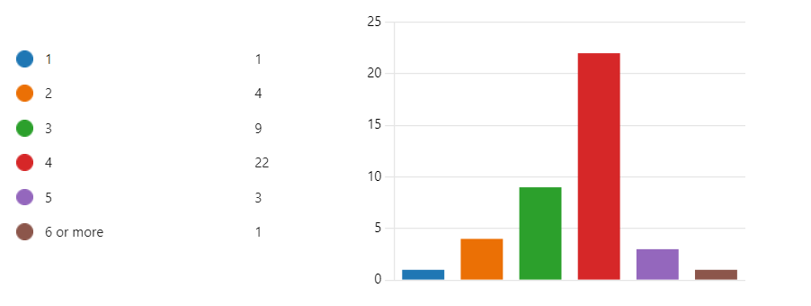

What is your Household's Ethnicity? (You can choose more than one)
We usually ask about the children’s ethnicity, so we have no direct comparative data. We know the census data show Cambridgeshire’s population as being 97% white, English, Welsh, and Scottish, so this return looks to be a reasonable cross-section given the numbers completing the survey are modest.
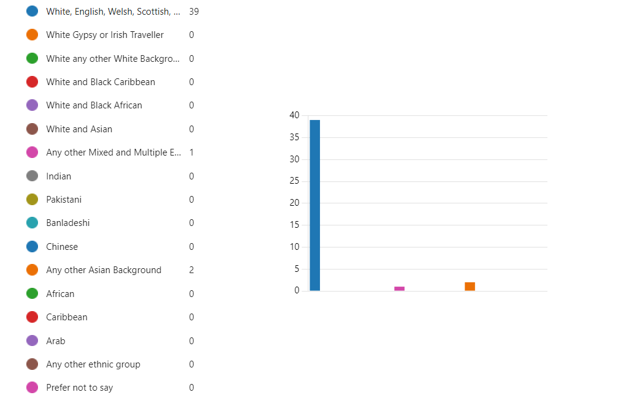
Please provide more details about the wider context of your family situation.
For example: single parent with 4 children and have own medical needs.
35% of adults who responded indicated that the adult carer has health needs.
70% of adults indicated they are single carers.

Tell us which part of Cambridgeshire you live in?
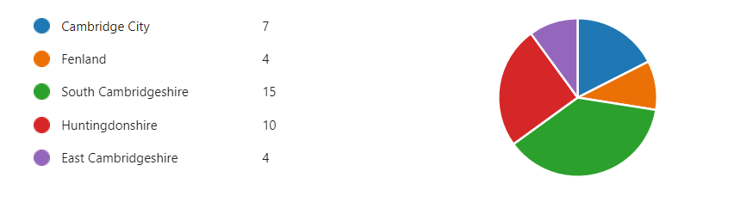
Please provide more details about the wider context of your family situation.
For example, a single parent with four children and have own medical needs.
Those completing the survey show a wide range of household arrangements, with a number of families reporting other family members with health needs.
Married with 4 children, one parent has own medical needs.
Married with 2 children, 1 child with SEND
2 parents 2 children
2 parents and two children. All neurodivergent and have medical needs
Mum has anxiety
Dad
One child ADHD autism and tic disorders
One child with suspected autism
Single parent 2 children have own medical needs.
Married with two children both children have own medical needs.
Single mother, self id autistic, 2 children, one of whom is autistic.
One child diagnosed ASD, POTS, non-epileptic seizures. I am also carer for parent with dementia in care home, plus I am a diabetic
Single parent
Single working autistic mum of one with on/off anxiety living with my parent who has ADHD and a range of physical/mental health diagnoses. My son is autistic, dyslexic and has ARFID, awaiting ADHD assessment and ongoing high anxiety.
Married couple, 2 children
Single parent of one toddler
Two adults three children one who has Down syndrome
Adoptive parents of twins, twin one has Down syndrome and twin two is undiagnosed but has early support. Adult birth son lives with us.
Single parent with 3 young children, one with significant special needs and medical needs
2 parents, 2 young adults
Two parents and two children (3&9)
9 yr old has medical needs
2 parents, one adult child, one teen, no medical needs
Two parent house with one send child (parents both working but increasing issues with health)
1 nonverbal autistic child with 2 parents
2 parents 2 children
Single parent with 2 Autistic children. Have own medical needs.
2 adults and 2 children both children have social communication difficulties
Single mother with disability needs, awaiting diagnosis neurodiverse child
Mother, father, 16yo daughter with anxiety disorder, 10yo son with ASD, PDA, SPD, anxiety, and ARFID
2 parents with 1 child
Two parents with 2 adopted children, both children have additional needs.
Married with one child at home (14). Two stepchildren no longer at home (24 & 21). I have ASD diagnosis & hypothyroidism.
Single parent with 1 sen child
married couple with one student and one child with additional needs
Two adults and two children.
2 parents, 2 children
Mum, Dad and 11 Year Old Son. Both parents have own medical needs also
2 adults, 2 children. One child with extra needs
Married couple, with 4 children. I have my own medical needs.
Single parent of 1 with own medical needs

How many Children and Young People with SEND do you have in your household?
Those completing the survey have smaller households of 1 or 2 children, although one family reporting 4 children didn’t answer this question.
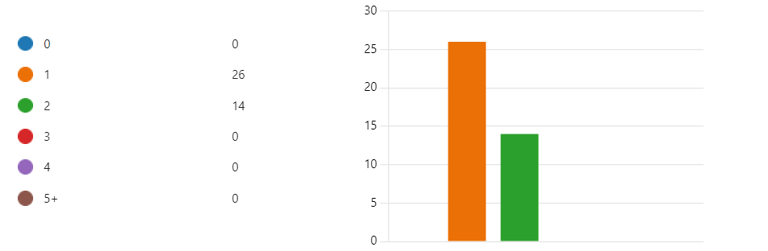
83% of respondents told us that all the children in the household had additional needs.

Any additional information you would like to provide about your child/children's SEND needs? For example: Age and gender.
Those taking part have children with a wide range of needs across the 0-25 age range.
12 years, boy
8 years, boy
4, male
12, girl, and 9, boy
5 boy
9 boy
Boy 6
Boy 9
Boy 20 , girl 17
16yrs old son 12yrs old daughter
Male 9 and 12
Female, 12
18 female
Autism non verbal
26yrs old male
Age 7, male Autism, ARFID, Dyslexia, Anxiety and likely ADHD but awaiting assessment for ADHD
15 yo AFAB identifies as male recently diagnosed autistic and ADHD
13 yo male displays features of being autistic, sensory processing difficulties from parents and school input to paediatrician, he is unable to access the in person part of the assessment.
Boy, three years, down syndrome
Female age 10
8, 12 both female
2.5 boy/girl twins
6, male, gdd and asd
13.....male
20 and 21, born female
Male 9 year adhd/sensory processing disorder / facial tics
Girl, 15
10, Male
ASD, ADHD, severe sensory issues
9, male
Primary aged male
14 boy
8 girl
11yr old girl ASD ADD dyslexia
8yr old boy ADHD dyslexia
9yo girl, medical conditions, mental health conditions and awaiting neurodiversity assessments, school avoider
See q6
11 boy
Female, aged 5, emotional needs due to trauma
, severe speech delay
Male, aged 3, suspected FASD, chronic eczema, small stature
14, born female but identifying as male. Been out of school nearly two years due to ASD anxiety, OCD, PDA. Unable to do home schooling, rarely washes, nocturnal, rarely leaves the house.
Age 6 male
17 Female
9 male.
Primary aged
Delayed development, learning difficulties, extreme anxieties and stress, dyslexia, multiple autistic traits, hypermobility, polydipsia and Critical Levels of Vitamin D Deficiency
9 year old male
Boy, age 12yrs
Boy, age 8yrs
Female 14 year old

Please tell us about your child/children's difficulties. (You can choose more than one)
The predominance of Autism and Social and Emotional Mental Health needs is not usual across the profile for Cambridgeshire. We have a good cross-section of needs covered by the respondents.

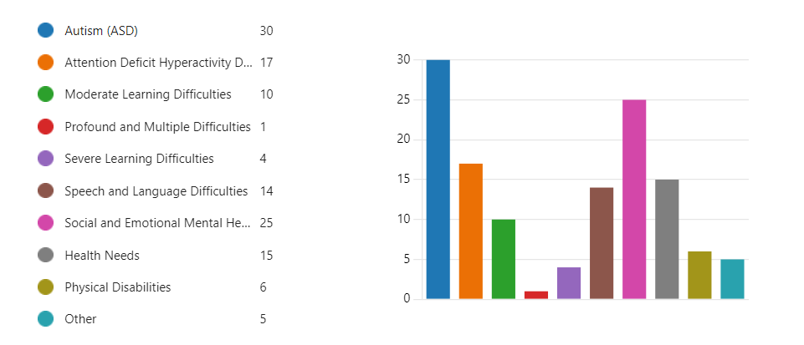

Have you tried to access any Health Services for your Children/Young People recently?
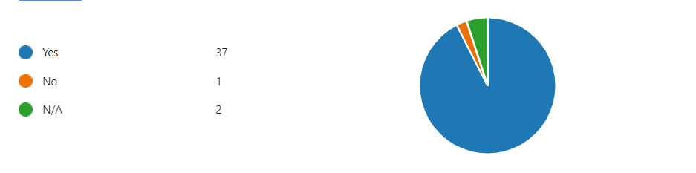

What services did your child/young person need to access?
There is a wide cross-section of services being accessed with GPs and Mental health services ranking highest. Whilst mental health services support a wide range of needs they also support those diagnosed with ADHD.
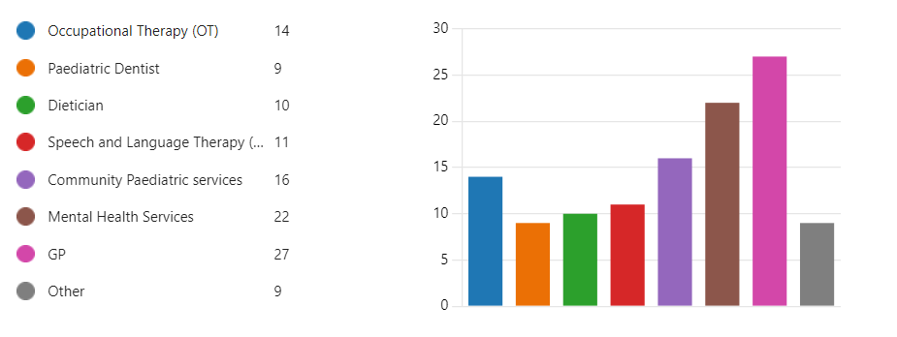
What was the reason for accessing the services?
The detailed reporting here shows the number who need support for poor mental health – anxiety and associated school attendance are reported a number of times. We also see feeding-related medical support. Some children are accessing multiple services. Dentistry is also accessed, including the special dentistry service.
Child needed additional support with daily tasks and speech and language
Worried about development, eating etc. have had paediatric appt
Excessive menstrual bleeding
Assessment
ADHD medication
Hospital appointments, grommets, tonsils removed and adenoids removed
OT support as out of school
GP for mental health
Community paediatrician for diagnosis
Suicidal, anxiety, depression
ADHD diagnosis and support with medication
Discuss son epilepsy with neurologist.
Mental health help
Dentist for check up as unable to access local dentist
Sudden seizures and fainting, and absences
Pain
Nutritional deficiencies, blood test, sensory sensitivities, anxiety
His needs due to Down Syndrome
Needed braces referred by dentist
ADHD /autism assessment
Support at preschool
Feeding
My son has arfid and has very low food and fluid intake.
Mix
Young Person 1 is autistic and has unhealthy eating habits. We had to take her to A&E and she then got support and had a five day stay in hospital to get gall- bladder removed.
Neurodivergent YP 2 got scalded with hot water and was very well treated by local GP.
On waiting list for 2 years! Still waiting
Anxiety (leading to severe difficulties at school); ADHD diagnosis (to be able to access help needed at school)
Assessment and care
GP - feeling unwell (infection)
Dentist - need to pull out 8 teeth under general anaesthesia, regular dental examinations
Community Paediatrics - assessment and diagnosis to comply with EHCP requirements
OT helpline for advice
GP for emergencies, ongoing medical conditions and for letters required by school to explain medical needs
Respiratory clinic following referral from GP
CAMHS following referral from school
Needed support with their mental health.
Diagnosis
Support with anxiety stopping school attendance
Non participation in school, suicidal intent, extreme distress around school, behavioural challenges, self harm, unusual development, developing OCD, unusual beliefs
GP for flu vaccination.
Dentist for check up.
CAMHS for mental health assessment to try to get support for anxiety and, initially, for school refusal but by the time he was assessed we had deregistered and commenced home ed.
Dietitian - GP referred as we had concerns about his diet, weight and nutritional intake.
Mental health so bad has not been to school for 4 years and nobody helping him. So getting violent with it.
As detailed above, complex health difficulties.
Child really struggling with mental health since puberty. Started self harming. Severe OCD. We felt out of our depth and that professional help was needed.
My needs an autism diagnosis
ill health
To gain information about using the right to choose for the ADHD assessment.
Mental health support for anxiety
Asthma clinic Addenbrookes
GP - various long term and short term health needs
My Son suffers from extreme anxieties and stress along with night terrors surrounding the Mainstream School he has been placed in so a Paediatric Doctor at the Children's Clinic at Hinchingbrooke Hospital referred him to Mental Health. She also diagnosed Hypermobility so referred him to Physio for a face to face appointment
Onset of tics
Struggling with Mental Health, and difficulties related to autism diagnosis
Waiting on so many services for my daughter, you can get hold of them, they can't help or answer your queries and just go round in circles

How long did you have to wait for the appointment to come through?

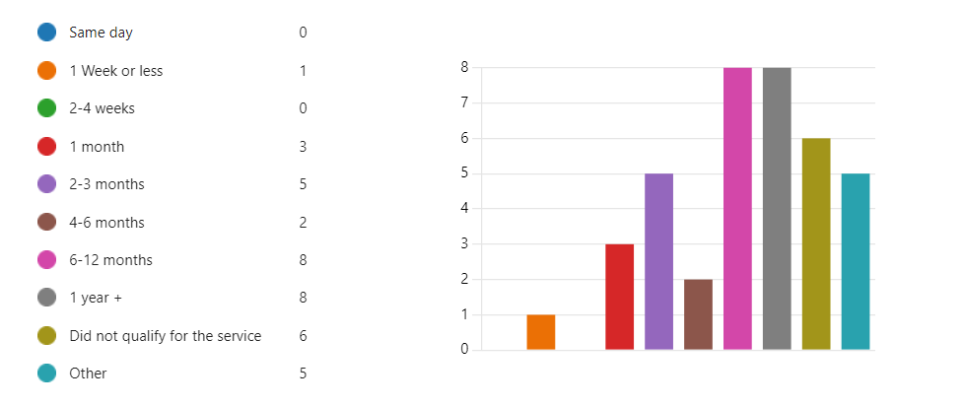
If you selected multiple services, please list the service, waiting times and reason for each here.
A wait of more than 2-3 months for specialist services is a long time and can significantly impact a recovery or an ability to access further / more appropriate support. There are a worrying number who have been waiting for more than 6 months. A wait of more than a year whilst suffering poor mental health is extremely worrying. The longest wait for services appears to be in paediatrics - Autism and ADHD- and Children and Adolescent Mental Health Services (CAMH) - poor mental health including anxiety, depression, Autism and ADHD.
Those who didn’t qualify are also high, and there is the supplementary question we could not ask: what support was provided as an alternative? There is a trend for families opting to pay for assessments, presumably because they consider the wait unacceptable and have the means to pay.

Speech and Language, still waiting.
Community paediatrician a long time
OT 6 weeks
GP same day
Hospital appointments 6 months
ADHD medication for just under a year
Waited over 3 yrs for CAMHS appointment and assessment then once received an appointment not properly assessed by Dr and discharged from the service.
Waited over two years to see a neurologist for epilepsy service
GP, same day, eczema flare
CAMHS, anxiety and depression, 18 months
Dental, wisdom teeth problems, took 2years to get them removed , and it would have been longer if it wasn't for an experienced mother who's son suffered with the same problems.
GP 4 weeks
OT 3 months for a group
Dietitian 4 months
ADHD assessment 40+ weeks
Wait was so long for ASD assessment, so I paid privately.
No local pathway for ARFID, so had to pay privately for the assessment.
OT - waited 6 months and only got referred as paid for a private report, and only then did his EHCP panel suddenly agree he needed referring (presumably so they didn't have to agree to the provision mentioned in the private report)
SALT - over 6 months and then received 4 appointments and now need to re-refer.
Community Pead - if I email, they get back to me in hours, amazing service.
GP- if I ring, I can generally get an appointment that same day
Paediatric dentist
Dietitian immediately
Salt 2 months
OT/physio 1 month
Dietician 1 month
Outpatients- Complex feeding appointment 6 months.
We could never get referrals for the things we needed and kept being shunted from school to doc to various other "services" who would just signpost elsewhere (circular process, and very distressing for both the children and the parents)
For emergencies recently, we have been very lucky.
For YP 1, the emergency would never have arisen if she had been assessed and treated at any stage during the previous 18 years (since adoption).
Camb H over 2 years
Dietician haven’t had response.
CAMHS - for anxiety - waited 8 months for initial phone assessment, another 3 months for access to app (constant threatening to discharge if we don’t reply immediately, including sending the threatening letter when they hadn’t sent an invitation in the first place!
CAMHS. - for ADHD - gave up waiting after 6 months and went private, because our daughter was in crisis.
GP -to discuss next steps; medication (as advised in ADHD diagnosis) -GP refused to see us. Asked why we didn’t go private for that, too!
Each appointment had massive delays from referral and acceptance due to pressures on services
GP - within the day
Dentist- 2-3 months, no availability
Community Paediatrics - a few weeks
OT - phone call only so just a few minutes wait
Mental health services - more than 2 years since referral
GP - emergency appointments on the day but advanced appointments about a month to wait
Paediatric dentist - initial appointment within a few months but waiting over a year for subsequent dentist appointment and about 6 months for acclimatisation appointments
Both
1yr CAMHS, 1yr community paediatrics still waiting, GP generally a few weeks, but seen the same day if the alternative is A&E
GP - 4 weeks for flu jab appointment as needed to be with specific nurse.
Dentist - complex as he often has to cancel at the last minute due to his anxiety.
CAMHs - 8 months.
Dietitian - unfortunately, I can't remember; it was during the first lockdown we were referred, then the first appt was several weeks/a few months later. Best guess is 6-12 weeks.
2 years for CAMHS, then a referral chased it up by a psychiatrist. It took 6 months to get a psychiatrist after one year of waiting for a paediatrician. Waiting for a dietitian from 3 months ago referral.
Community Paediatrician for my son was over a year wait, we went private in the interim.
Same for Speech and Language, paid for private treatment due to wait times, the severity of the issue and school start date impending.
Paid privately for both children to have their ears syringed, have no idea how long the waiting lists would be but as neither have any pain response I was worried about reoccurring ear infections.
CAMHS - 6 months
SALT & OT - never had an appointment as no service provided in my area.
GP - period pains severe - I could not get an appointment on her behalf because she can't talk on a phone so can't give her consent for me to talk on her behalf. We go online to the surgery for her no problem.
mental health - ADHD and anxiety treatment sought - was dismissed without help after 18 months in the system
eye problem - has telephone appointment next week after urgent referral for pea-sized lump under in April 2023. 3 previous appointments have been cancelled by the hospital.
GP - on the day for urgent needs. 1 month for non-urgent/m / long term
YOUNITED/CAMHS - more than 2 years after initial referral
Asthma clinic - 1 month
The Mental Health Appointment was about 2 months as it was quite urgent he be seen. Physio Appointment has come through for February, so about 4 months. The GP referred to the Paediatric Doctor. I can get same day GP appointments. It took about 2 months for the Paediatric Doctor Appointment to come through. I can not for love nor money get our SENCO to refer our Son to the Community Paediatrician for another Assessment because he isn't showing 'violent tendencies', plus he said it will take about 100 hours work to do the referral!!!!
GP 3 weeks
Paediatrician 2 days
CAMHS 5 months for assessment (expedited) and now on another waiting list (3 months so far) for the support needed
GP -2 weeks
SALT - 12 months
OT - did not reach threshold
Paediatric dentist - 3 months
Mental health - still waiting (1 month)
Would take too long to look through all this

What impact did the waiting times have on your Child/Young person and the rest of the family?
The impact isn’t just on the child; there are consistent messages about the impact on other family members, specifically the main caregiver. If you consider the choice of vocabulary, you are struck by the words used to describe the size of the impact – huge, large, severe and catastrophic. A number of reports reference missing schools or being unable to attend – this time is lost forever. The references to children in crisis and pain make these hard to read.
It has been difficult.
Large impact as it affects day-to-day life
Waiting time is not an issue here
Anxiety
ADHD medication was a long time, and lots of time wasted having to jump through hoops that have had an absolutely horrific impact on the family. I now suffer badly from anxiety.
The situation got much more complex.
I had lots of mental health difficulties, and I took my child to A&E on a few occasions due to suicidal ideation. Mental health difficulties due to no support when my child received the epilepsy diagnosis at a young age. There was no support for parents with an epilepsy diagnosis on how to manage seizures, the impact it had on my child's education, the memory loss due to seizures, and the impact the anti-epilepsy medication had on my son's mental health and memory.
Made it incredibly hard and forced us to look privately. We have only had an assessment, no actual help
CAMHS Missed out on school, now very isolated at home and not engaging yet with them
Keep being called out of work to collect her from college due to fainting and seizures, and no medication or interest in her issues from NHS. sibling being left to get themselves home from school 3 miles away as a consequence. Long hours in A&E. Child felt no one was interested in her.
It impacted everything for us and my son. It has been awful seeing and having him suffer with pain.
Increase in anxiety/stress, feeling isolated and alone, deteriorating mental health and no help offered whilst you wait.
Dietician - waited three months after referral.
Seen very quickly
In limbo - was told to refer to school SENDCo despite the school not seeing any symptoms due to making. The school won’t make any referrals.
The child cannot attend preschool.
A lot of anxiety for me; my son wasn't able to communicate awareness of it going on. The first appointment was very inconvenient with my other children (needing to bring a 2-year-old to the appointment). I got told that was the only appointment available until after Christmas (this was October). So that added pressure for me for an appointment.
Stressful
Refusal to assess one child led to a mental breakdown after the first week in secondary school, and then eventually sent to an inappropriate special school, which failed her. The major, major financial impact on the family is that one parent is unable to work outside the family, and the other has to reduce working hours also.
Other (older) young person has private diagnosis of ADHD and is still awaiting NHS assessment for autism and to be seen by gender clinic (already waited 3 years, 5 to go...). Major impact on self-esteem and confidence and needs above-average support from parents.
Severe - parents both suffering stress-related depression, one-off work.
Catastrophic. She lost nearly a year of school and was suffering from depression and anxiety, affecting every aspect of her life because she was struggling so badly without support. This will dramatically impact her GCSEs, due to missed school, and thus her future. The impact on the whole family, with the stress this has caused and the trauma of dealing with this unsupported, has been huge. We have felt completely alone, except for her (overworked) SENCO, who is now, belatedly, able to offer her some adjustments. Neither the school nor the GP had any idea how the system worked, so we have had to spend a huge amount of time trying to muddle our way through. Following private diagnosis, the GP has refused to see her to discuss medication or advise us on what to do now, so we have not even had the opportunity to raise the issue of potential autism and we have had no advice on how best to support her.
Huge - lack of help and assistance, all riding on appointments that take forever to come. Intervention and help months/years again to wait
Dentist - child was in severe pain, having frequent meltdowns, self-harming as well as harming everyone else, crying and screaming in the dead of night, unable to eat, sleep or function properly, needed to be on paracetamol 24/7 and week upon week of different antibiotics, several trips to emergency dentists and even A&E, no reprieve and/or alternative solution offered.
OT - great to get advice from helpline so quickly
GP - long waits for non-emergency appointments mean longer with chronic conditions and additional pressure from school to get letters impact on our mental health and relationship with school. But GP are very good getting the same Dr and all staff are very patient about my child’s needs
CAMHS - this long wait has impacted all our lives hugely and will continue to - the damage will last all our lives now. My child has lost 2 years of their childhood and their life chances altered and their education has stopped as they are too unwell. We have been stretched to close to breaking point caring for our child. Our other child is also struggling and now needs mental health support too.
Dentist - long waits between acclimatisation appointments make them less effective. Luckily no ongoing dental problems so the impact isn’t as much as it could have been.
Respiratory clinic - waiting time is ok as was only about a month and gave us time to plan work/childcare and also prepare our child as they need some advanced notice about appointments
It's impacting greatly. I'm feeling burnt out.
Huge. Diagnosis isn’t everything, but it helps to get extra support currently. GP unable to access anything more or any further support. Impact on the whole family with emotional needs plus parable to go to work or having to miss work and be unpaid.
As the only breadwinner, I am on the verge of losing my job due to my daughter’s inability to attend school regularly. I am unable to cope with running my home or parenting adequately. I have needed to take psychiatric medication and sleeping tablets. My Family feels traumatised. None of the referrals were put through until things were desperate for fear they would not have been accepted, so support was required immediately! I am not sure my confidence as a parent will ever recover. I feel the risk my child has been put at by the wait, as well as the reinforcement of coping behaviours, is unacceptable, and I fear unrepairable. Her difficulties now seem so entrenched I think more support will be required to help. My daughter has fallen further behind academically and her relationship with school has broken down entirely. She has lost years of her childhood to acute distress.
The long wait for CAMHS was the biggest impact. We ended up taking him out of school for the sake of his mental health while we were waiting - his anxiety was extremely high and prevented him being able to leave the house even for things he used to enjoy. By the time he was seen, his mental health was improving because we had taken him out of school to home ed.
Anxiety increased, so unable to attend school or home. Become medicated now for Anxiety. Self-harming and OCD have now developed, leading to medication.
Financial implications as we have had to self-fund treatment whilst waiting on an NHS waitlist. We were on universal credit at the time due to low wages, so we clearly could not afford private treatment, but it was in the best interests of both children in the circumstances.
The whole family’s mental health deteriorated. Even when we got an appointment with CAMHS, they didn’t believe us and just offered us a parent support group. I was nearly suicidal following that appointment.
Upset, let down.
Reduced her already low self-esteem: she concluded that not getting care was just inevitable for her because she was not worth it - here it was happening again. She spent a year hiding her face behind her hair (a year because it took four months to get her to seek help for the lump under her eye). She is a violinist applying to music college, and this has affected her ability to play as well.
My daughter's mental well-being was terrible, and an 18-month wait to then be dismissed without treatment during her teenage years has had a huge impact because she remained dysfunctional and anxious. The rest of the family has been under severe stress around her. I have had very poor health.
We are still waiting for an update from an appointment in mid-December. This causes a great deal of stress and frustration.
GP - Waiting for non-urgent appointments meant it took a long time to get evidence to refer to an asthma clinic; the child suffered from asthma for many months.
GP - it’s good we can get urgent appointments on the day if needed
Mental health - devastating impact, deterioration of mental health over time; mental health problems now impact all aspects of life, including education and physical health. Things have got worse during the wait and will take longer to get better, using more resources than would have been needed had help been available 2 years earlier. The impact is also devastating to the whole family - the health and well-being of siblings and parents have also been impacted by having to care for a child with mental health difficulties without any support.
My child's Mental Health has suffered considerably due to the School the LA put him in, which cannot meet his needs. My Son is now having suicidal thoughts, which I discovered at the first face-to-face Mental Health Meeting. I was diagnosed with Trigeminal Neuralgia, which brought on my stress and extremely high blood pressure within a month of my Son starting at this school. He is no longer a happy little boy, so needs to see these professionals whose reports can help with getting him out of this School
Anxiety has now resulted on a child experiencing extremely distressing tics all day, every day, which in turn make him more anxious
We feel abandoned, even though we were told to ask for help when we need it
Stress, anxiety, school refusal, and poor health has deteriorated

If you tried to get an appointment for your child/young person but were not offered one, what action did you take to try and resolve the issues?
Clearly, some parent carers can advocate and are dogged in their persistence, but others have simply walked away. There are references to needing to make formal complaints and parent unhappy about their child’s treatment. IN some cases there are reports of multiple potential points of failure across the system with some children have particularly difficult experiences.
Gave up and looked for other ways to try and help my child.
I didn’t!
I got offered a blood test appt but no support for an autistic medical phobic child to actually access the appt. So the child could not access the service.
Went to PALS and complained and got the ADHD appointment
Constant DRs visits
After the CAMHS appointment I was not happy with the assessment received or the way the Dr spoke to me. A PALS complaint has been raised and have taken it further. The complaint is still outstanding I have not had a response for over 6 months now its a terrible service.
Dentist. None as yet, too many other battles to fight
First, the doctor's not interested- The paediatrician walked out of the room as she went into a seizure; Dr at Peterborough wrote and said he didn't need to see her and to read a website. A&E turned her away after a 2-hour seizure and being taken in by ambulance. Ambulance crews said she was faking seizures. Addenbrookes said out of catchment, so it shouldn't have been referred there. Ended up paying privately -diagnosis immediately of POTS brought on by covid, medication prescribed and immediate results. For seizures, the neurologist arranged MRIs, followed what we had discovered by keeping a record of seizures, and prescribed mini-pill as seizures seemed to be linked to hormones - no seizures since.
We got emergency appointments, but they didn't listen and just put on strong pain killers antibiotics, been a nightmare
Contacting the service directly and then complaining through PALS/formally
OT - paid £500 for a private OT assessment, and then suddenly got offered NHS provision.
No
Waiting for symptoms to become worse as they get older
We tried all sorts of ways, phoning, emailing, and requesting referrals from other "professionals". Schools, notably, are particularly unsupportive in our experience. The older child found a school prepared to accept them and was expecting to start Year 10 there, but LA denied this despite parents being prepared to transport child (12-mile round trip, rather than within walking distance)
Chased numerous times
See above - went private for ADHD assessment (knew that we would wait years otherwise and risk dangerous consequences for her mental health). We have not pursued the issue with the GP because our efforts have been focused on everything else that our daughter needs (advocating for her at school, supporting her, educating ourselves to better support her needs) and there are not enough hours in the day! We have tried, and failed, to find an alternative GP practice, due to them not taking patients from outside catchment.
Writing/complaining to PALS
We needed to call again and again to confirm a space, each call an hour or over, and we went to A&E as we were desperate; the appointment could not be bumped up, nor any helpful treatments nor helpful pain relief was prescribed. Our child had to endure pain and suffering for three months until the date of his operation. Being nonverbal, it was doubly difficult for him and for us to cope. He lost a lot of weight, and we felt defeated and let down by the NHS service, whom we felt did not share our sense of urgency, and did not appreciate the severity of our situation. It was extremely horrible and traumatic and left everyone in our family bruised and battered physically, mentally, and emotionally.
We went to the private sector where we could. We also wrote to the services to request they reconsider (school also wrote to them, which probably had more impact) and our child was put on a waiting list for an appointment
Currently on waiting lists for both children.
Contacted Pinpoint for support.
I just waited for most of them, GP chose to try and get community paediatrics appointment expedited due to the potential risk of family breakdown, so we should be seen soon.
Kept contacting the Paediatrician and CAMHS
Paid for private treatment.
CAMHS had nothing to offer an autistic child, apart from medication. We sourced a private psychotherapist instead, which has cost us thousands of pounds, and continuing to.
I rang again/ looked for another number or website to contact. asked if there was anything else I could do. With the eye problem, I was at first sent by the doctor to an optician, who no longer dealt with the problem, so I looked online and spoke to my sister-in-law who is an optician elsewhere for advice. I contacted the doctor again to get the right contact. When the appointments were cancelled I rang back. When there was no real progress I contacted the doctor again and asked what to do and she expedited the case. I kept in contact with my sister-in-law.
For the mental health/ADHD, I have gone privately for some help, but this has been very difficult to afford. The issue is unresolved and years have now passed.
For the period pains, unfortunately, my daughter is still missing a day from school in a lot of pain each month and this needs resolving.
Kept going back to the GP to explain the problem and that it hasn’t gone away, eventually we were referred.
I am still fighting to get someone to do a referral to the Community Paediatrician but as the GP can no longer do this it comes down to the SENCO at the School. Don't know what other avenues to try
Called, emailed. You have to keep chasing
Went private for OT at great cost to us.
Tried complaining but never got anywhere

n/a
It seems nobody knows what to do with a 12yo who needs support to overcome the fear of medical treatment. There is no pathway so no referrals are made.
I think it is shameful that children who need help are left waiting and simply given the option of calling 111 if it gets worse. I don't want things to get worse, so I have had to spend what little savings I have to try to access help
Whilst getting GP appointments has been ok, actually accessing the surgery is extremely difficult due to social anxiety, busy waiting rooms, unpredictable waiting times and fear of doctors.
Completely failed by NHS -said she was faking the seizures and that it was linked to anxiety. Have not been taken seriously that it has all started since having covid and covid vaccines.
The maxillofacial clinic , we had appointments to see them, but they didn't feel the need to get his wisdom teeth out, but since he had them out, everyone has noticed the difference in him , so much better , but now we have a problem with a tooth decaying.
Extra funding needs to go into neurodevelopmental CAMHS and improving access to assessments for autism and ADHD. We need a local ARFID pathway in Peterborough/Cambridgeshire
Portage isn't offered in Cambridge but is offered to nearly all other children with Down Syndrome in the UK. This is unfair and discriminatory. I paid for some private sessions, but as a single mum, teaching part-time, I don't have much spare money, so my son only had a few.
Still waiting for equipment from OT ordered September
CAMHS were unable to engage with either youngster in the past - not trained to deal with autism and developmental trauma.
Waiting times for CAMH are ridiculous. We’ve been waiting 2 years, and still no appointment
Difficulties in any vaccination being given mean son not been able to have vaccines
It would be helpful if services gave more information about what they will do to prepare our children for an appointment. Appointments cause a lot of anxiety, so the more certainty about the appointment, the better. A few pictures on the website of the clinic, waiting room and possibly any known tests the child will be having would also be helpful to prepare the child.
Because I am a full-time parent with no childcare due to my daughter's need, my daughter has to attend my medical appointments. This limits my ability to focus on the interaction or say a lot of what would be useful. I tend to avoid smears, vaccinations or any discussion of mental health because my daughter won't cope.
The original concerns of mine were Dec 2019 and he is only just getting the help. This allowed the issues to get out of control by not taking the concerns of parents seriously and just following a generic pathway. Not able to get my child to them either so he was dismissed constantly. Catch 22, as he needs help to leave the house!
The treatment my children have had from the NHS has been shameful given their backgrounds and the level of support they require. Parents should not be self funding private treatment for their children because of the impact waitlist delays have on children's development.
CAMHS is a postcode lottery when it comes to supporting children with autism. There are not enough people trained to deal with autism.
It would be useful to be able to feed back to health teams about what went wrong in an appointment and how to better support our child next time.
All health staff should be reminded to ask for and wait for consent before touching a patient and to stop when they are asked to stop. If this doesn’t happen, it can lead to such high anxiety about Drs, hospitals, etc, that a child may be too scared to return.
It would help if staff understood that autistic patients, in particular, may not be able to do as much as they hoped in an appointment, but pushing things too far may increase anxiety about medical appointments to the point they don’t feel safe to return. A phone call to parents beforehand to take a medical history would decrease the stress on the child. Also reducing the number of staff in the room and stopping when the child (or their parents) indicates that they have reached their limit.
Just how angry I am at the LA and my Son's lack of Case Workers for his EHCP, who have placed him in a School where he is severely suffering due to what they've done
Also, I am still waiting for the ADHD assessment outcome. Had a QB test in early Nov. Adds to anxiety.
N/A

If you had a positive experience with your child/young person's service provider please comment about it here
Considering this is the same group of parent carers who detail some difficult and worrying experiences, it is pleasing to see that many are praising the individual professionals whom they have interacted with.
Holly ward is absolutely amazing with suspected ASD child having the operation and then having to stay in
Not positive apart from telephone appt neurologist at Addenbrooks.
Social worker and people involved helped to push and write letters, but it seemed they were being ignored too.
Outpatient Dietitians based in Cambridge are amazing, GP Wansford great
Community paediatricians for Down Syndrome are amazing.
Cambridge Orthodontist Practice Long Road. Excellent service and good experience of working with children with learning disabilities.
Dietitian is amazing
The dietician and complex feeding clinic were very respectful of my son's sensory needs, and I didn't need to explain his needs.
The ambulance crew were very attentive and supportive after the overdose 2 years ago.
A&E and the local GP (at the new address) are pretty helpful!
Emergency dentist (Cambridge) - very empathic, patient, kind; unfortunately, could not help beyond prescribing antibiotics
GP - every member of staff (GP, nurse, receptionist and office staff) is patient and understanding about our child’s needs, and they make reasonable adjustments (eg waiting in the car park, same Dr where possible, remaining calm and understanding when my child is too overwhelmed for more examination). We have been impressed with the approach of the GP practice especially as we know how overstretched they are. This approach has helped with our child’s anxiety over medical appointments (still a long way to go, but just having an understanding GP means so much to our family, especially when we are used to being judged and shouted at about our child’s needs by other organisations, e.g. the education system).
Child Respiratory clinic - again, the staff have been really understanding of the child’s needs and phoned in advance of the appointment to check what reasonable adjustments would be appropriate. Also booked a longer appointment and quieter waiting space.
OT - it’s great to have the helpline for advice on OT subjects. I will definitely use it again.
A&E - not strictly an appointment but they were also understanding of child’s needs and read and followed the hospital passport.
Once appointments are gained with Community Paed it’s a positive process but hard to get the referral and it’s a huge wait.
The CAMHS worker is lovely and patient with my child. The GP surgery allow my daughter to attend my medical appointments
Nurse - understands my son's difficulties and is happy to accommodate: she asked GP to agree he could have injection instead of nasal spray, and came out to car park to administer so we didn't have to go into waiting room.
Dentist accommodates as far as possible, allowing last minute cancellations and giving us double appt so he can put my son at ease before doing the check-up.
Dietitian - very understanding, knew about PDA and the impact it has on eating especially when combined with sensory processing difficulties.
The psychiatrist excellent was seen
We have not had any positive experiences.
All the professionals I went to for help were very polite and kind.
GP understands the impact anxiety has on wider health and goes at child’s pace. All staff at GP are understanding
Offered a separate quiet waiting room in clinic 6 Addenbrookes.
The lady who saw for his Mental Health problems was absolutely great and has referred him for CBT. I already have the appointments for these, four face to face appointments
Paediatrician. I called after not getting a response to my email and got a call back that day. Very empathetic and helped guide me as to where to go next.
Specialist dentist clinic was really good and knew how to work with him.
None, all been negative

Comparative Feedback from our Annual and Mid-Year Surveys
Oct 2023
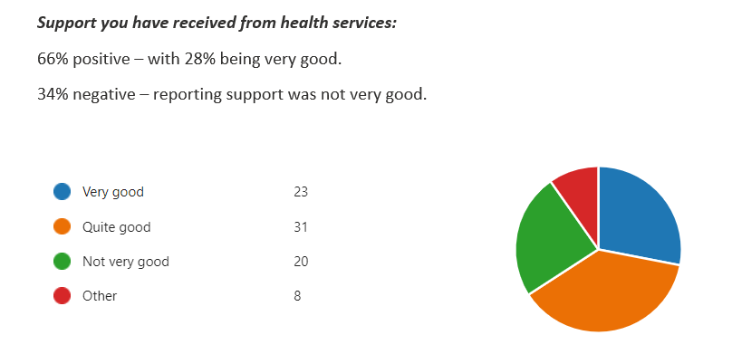
March 2023
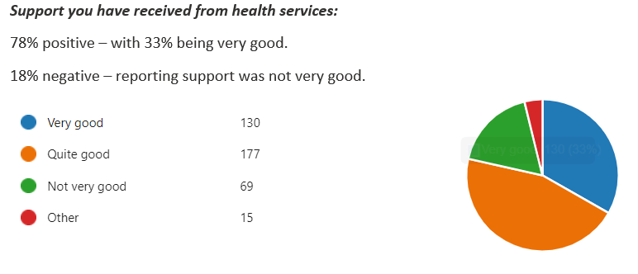
March 2022
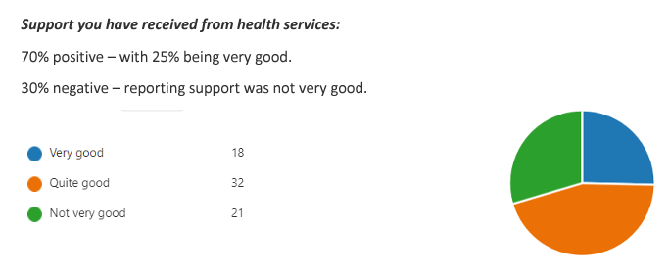
March 2021
